Miss Hotchkiss’ 7th Grade Science 2018-2019 Syllabus

**Welcome to 7th Grade Science!**

I am so excited to begin my 5th year of teaching at West Ridge Middle School and getting to know each and every one of you! Science is interesting, dynamic and fun and I cannot wait to teach you more about the world you live in! I have always loved science and I’m thrilled to share my passion with you! Here is the breakdown of this year!

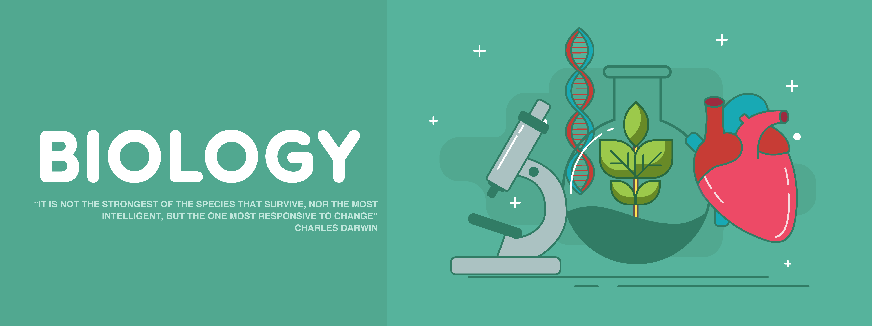

7th Grade Science primarily focuses on Biology, or the study of life! Here are the main topics we will be covering this year:

* **Scientific Inquiry**
* **Molecules of Life**
* **Cells and Cell Processes**
* **Human Body Systems**
* **Meiosis, Mitosis, and DNA**
* **Genetics**
* **Natural Selection and Adaptations**
* **Ecology**
* **Earth Systems, Weathering, Erosion, and Deposition**
* **Manned Space Exploration**

**Needed Supplies:**

* 1 package of 12 pencils
* 1 package of 12 colored pencils
* 1 package of markers
* 1 package of lined index cards (100 count)
* 1 package of glue sticks
* 1 hand-held pencil sharpener
* 1 pencil bag
* 1 (2 inch) 3-ring binder (strictly for science)
* 1 package of notebook dividers (5 dividers)
* 1 Homework folder
* Clorox wipes
* Dissection gloves

**Grading Policy:**

* Daily grades make up 40% of the student average. This includes warm-ups (50-70 points), homework checks (50 points), learning checks (100 points), quizzes (200 points), graded assignments which can be anywhere from 25-150 points depending on the length of the assignment. Warm-ups are graded every 3-4 weeks and are through Google Classroom!
* Major grades make up 60% of the student average and consist of tests and major projects.
* Homework is graded. All homework assigned will be given graded on accuracy or completion. All homework assignments will be recorded in the 40% Minor grade category.

**Retesting:**

* Students have the opportunity to retest within **5 days** of getting tests back. Students will be asked to fill out a Retest form which will indicate where confusion may have occurred. Afterwards, students will be asked to study their corrected test/notes and come in to retake the **entire** test. The second and hopefully improved grade will stand and be entered in Skyward. Students are only allowed to retest once per unit test.

**Textbook**:

The science department uses a textbook called *iScience* by McGraw-Hill.

Students are encouraged to use the online textbook which can be found using the following link: <http://connected.mcgraw-hill.com/connected/login.do>

Instructions for how to access the online textbook will be given during class.

Students are allowed to write in their textbooks and they do not have to be returned at the end of the year.

**Please feel free to contact me!**

Email: [bhotchkiss@eanesisd.net](mailto:bhotchkiss@eanesisd.net)

Phone: 512-732-9220 and my extension is 32212

**Tutoring times will be posted on my website during the first week of school!**

**Miss Hotchkiss Rules!**

Let’s go over the 7th grade expectations to make sure we are all on the same page!

**BE RESPECTFUL**:

* How can you show respect for your teacher? ___________________________________________________________________________________________________________________________________________________________________________________________________________________________
* How can you show respect towards your classmates? ___________________________________________________________________________________________________________________________________________________________________________________________________________________________
* How can you show respect towards yourself? ___________________________________________________________________________________________________________________________________________________________________________________________________________________________
* How can you show respect towards our classroom? ___________________________________________________________________________________________________________________________________________________________________________________________________________________________

**BE RESPONSIBLE**:

* A responsible science student should bring the following materials to class everyday:
  + __________________________________________________
  + __________________________________________________
  + __________________________________________________
  + __________________________________________________
* A responsible science student SHOULD NOT bring: ____________________________________________________________________________________________
* What are some actions you can complete to take responsibility for your learning? __________________________________________________________________________________________________________________________________________________________________________________________________________________________

**BE SAFE**:

* It is EXTREMELY important to practice correct lab safety habits in a science classroom. Please name 4 lab safety rules that you remember from last year:
  + ___________________________________________________________________________________________________
  + ___________________________________________________________________________________________________
  + ___________________________________________________________________________________________________
  + ___________________________________________________________________________________________________

What happens when rules are broken?

**First Offense**: Verbal Warning

**Second Offense**: Teacher-student conference

**Third Offense**: Parent contact

**Fourth Offense**: Office referral